**ME 222**

**NATURE AND PROPERTIES OF MATERIALS**



**Lab Report**

**Experiment No. : 5**

**CRACK GROWTH**

Instructor: Dr. Kamal K. Kar

Department of Mechanical Engineering

Group – A2

14042 Affan Ahmad

14048 Akash Singh

14052 Akhil Amod

14059 Akshay Bagde

14060 Akshay Bhola

14062 Akshay Sharma

14065 Albart Jose

**AIM OF THE EXPERIMENT**

* To study the crack growth characteristics of an elastomer under tension and compression cycles.
* To measure the crack length versus number of cycles, plot graph between them and analyse.

**INTRODUCTION**

* **Fatigue:** It is a form of failure that occurs in structures subjected to dynamic and fluctuating stresses (e.g. bridges, aircrafts, machines etc.). Under these Circumstances it is possible for failure to occur at a stress Level considerably lower than the tensile or yield strength for a static load.
* **Cyclic Stresses:**  It is the distribution of forces that change over time in a repetitive fashion. Fatigue failure is typically modeled by decomposing **cyclic stresses** into mean and alternating components.
* **Elastomers:** They are amorphous polymers existing above their glass transition temperature, so that considerable segmental motion is possible. The use of elastomers in today’s life is indispensable. Some of their applications are sound absorbers, waterproofing materials etc. Due to their intensive use in the industries they are supposed to have a higher fatigue life so that they can last long and can be used for a longer time without replacement. Hence in order to achieve this elastomers undergo many fatigue tests. Elastomers often wear out due to development of cracks formed due to imposition of cyclic stresses.
* **Synthetic Rubber**: A synthetic rubber is any artificial elastomer. These are mainly polymers synthesised from petroleum by-products.

**THEORY**

**Crack Growth involves the following three processes:**

* **Crack Initiation:** wherein some crack forms at some places where stress concentration is high
* **Crack Propagation:** wherein the crack grows incrementally with each stress cycle.
* **Final Failure:** when the crack reaches its critical stage, rapid failure occurs and material breaks.

Cracks associated with fatigue failure almost always initiate (or nucleate) on the surface of a component at some point of stress concentration.

Crack nucleation sites include surface scratches, sharp fillets, keyways,

threads, dents, and the like. In addition, cyclic loading can produce microscopic surface discontinuities resulting from dislocation slip steps that may also act as stress raisers, and therefore as crack initiation sites.

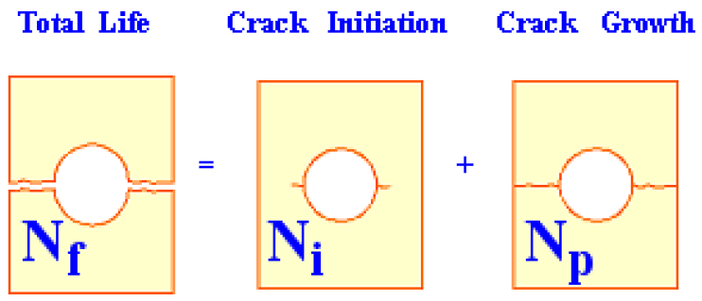

The fatigue life cycle: the number of cycles to which the material fails is given by N(f). The number of crack initiation cycles is given by N(i). The number of crack propagation cycles are given by N(p). These are related by the relation

**N (f) = N (i) + N (p)**

**MACHINE:**

Fatigue Testing Machine consists of horizontal plates between which we fix our material to be tested. The top plate is fixed which other plates are moved up and down with the help of a motor. The motor rotates a disk .A rod is connected to the disk near its periphery. The rotation of disk moves the rod which is connected to the horizontal plates and hence moves it up and down. In this way cyclic load is applied on the elastomer sample fixed in between the stationary top plate and movable bottom plates.

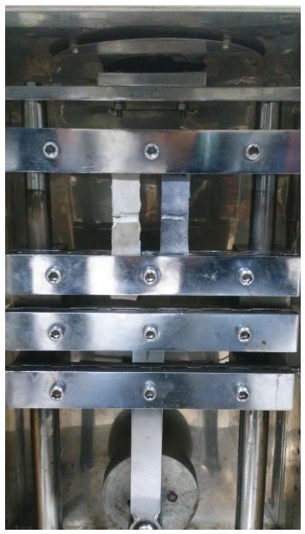

**Specifications:**

**Load Cell Motor:-**

Single Phase

220V

1440rpm

P=1/2hp

370W

**Control Panel Motor:-**

Single Phase

0.55A

230V

50Hz

1/35hp

21W

1280rpm

**SAMPLE:**

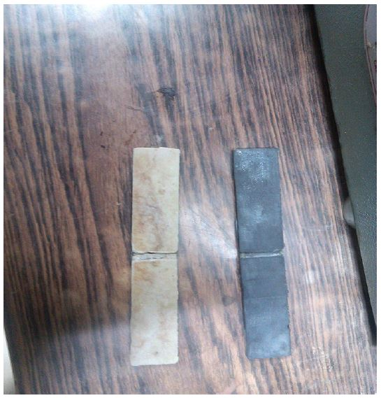

In the above figure the left one is natural rubber and the right one is synthetic rubber.

**PROCEDURE**

* Measure the dimensions of the given Elastomer samples.
* Insert the elastomer sample tightly into the machine holder
* Switch on the fatigue testing machine and let it run for few cycles
* Measure the amount of growth of crack after a period of each 200 cycles and record it in the observation table
* Plot the required graph

**OBSERVATION TABLES AND GRAPHS**

The two rubber samples provided are

* Simple rubber having no carbon in its composition (easier to stretch with hands)
* Carbon mixed rubber (Stiffer to stretch with hands)

**Specimen specification**

|  |  |  |  |  |  |
| --- | --- | --- | --- | --- | --- |
| Synthetic Rubber | Length(cm) | Width(mm) | Thickness(mm) | Notch Width  (mm) | Notch  Depth  (mm) |
| Carbon | 14.85 | 24.82 | 6.62 | 5.02 | 2.02 |
| Without-Carbon | 14.95 | 24.94 | 6.48 | 4.92 | 3.94 |

**Observation table for rubber samples**

|  |  |  |  |
| --- | --- | --- | --- |
| S. No. | Number of Cycles | Crack Length  (without carbon)  (mm) | Crack Length  (with carbon)  (mm) |
| 1 | 200 | 0.00 | 0.00 |
| 2 | 400 | 0.00 | 0.00 |
| 3 | 600 | 0.00 | 0.00 |
| 4 | 800 | 0.02 | 0.00 |
| 5 | 1000 | 0.05 | 0.00 |
| 6 | 1200 | 0.70 | 0.00 |
| 7 | 1700 | 1.08 | 0.05 |
| 8 | 2200 | 2.12 | 1.26 |
| 9 | 2700 | 3.45 | 4.98 |
| 10 | 3200 | 4.24 |  |

Crack length Vs. Number of cycles in Rubber with carbon and without carbon

**RESULTS**

* Rubber sample without carbon content failed after 3200 cycles
* Rubber sample with carbon content failed after 2700 cycles

**APPLICATIONS**

* Use of fracture mechanics in fatigue crack growth and damage tolerant design requires knowledge of “pre-existing” cracks, either assumed or found using non-destructive flaw detection techniques.
* Fracture mechanics has been used heavily in the aerospace, nuclear, and ship industries with a recent extension to the ground vehicle industry.
* Fracture mechanics is used to evaluate the strength of a structure or component in the presence of a crack or flaw.

**PRECAUTIONS**

* Handle the rubber samples carefully
* Do not stretch the samples with hand before testing as it may produce residual stress before the experiment
* Operate the machine carefully
* Make sure to close the door of machine before starting it.
* Fix the sample properly between the plates.
* Make sure that both the rubber samples move in the same direction when applied cyclic load.

**Reference:**

* Materials Science and Engineering: An Introduction, by William D.Callister , David G. Rethwitch
* Wikipedia
* <https://www.efatigue.com/training/Chapter_6.pdf>
* Lab Manual